Jahia Book
Chapter 1- Introduction

Jahia
9 route des Jeunes, CH-1227, Carouge Switzerland
http://www.jahia.com > The company web site http://www.jahia.net > The community web site

Version
This table records the versions of this document and their last updates
Version | Author | Date | Modifications
1.0 | Jonathan Coates | 2008-03-19 | Initial document
1.1 | Stéphanie Rouaud | 2008-07-08 | Add missing chapter

Summary
Page
Version 2
Summary 3
Vision 4
Jahia Overview 5
What is Jahia? 5
Jahia Core Features 5
New Features in Jahia Release 6 6
Typical Jahia project structure 7
Project scoping variables 7
Key Jahia Features 9
Definition of user roles in Jahia 9
A brief history of Jahia 10
Blobs 11
The Jahia Publishing process 11

Vision

Jahia Overview

What is Jahia?
The Jahia product is a highly configurable and personalizable web presence platform, composed of multiple standard open source frameworks, which can be used to create Intranet, Extranet and Internet sites and allowing the integration of multiple data sources into a single coherent and consistent user experience.
Jahia Solutions Group is a Swiss-based commercial entity, founded in 2003 (?), supporting the Jahia product development and client implementations worldwide, through training, specific technical assistance and technical support.

Jahia Core Features
As an Enterprise Class Software, Jahia offers out-of-the-box full customization capabilities along with:
- Enterprise Content Management
- Document Management
- Collaborative Tools
- Personalization Engines
- Portal Management
It is 100% written in Java and integrates the best existing Open Source libraries and frameworks, notably from the Apache Foundation. These include:
- Dynamic web site management tools
- Content management functionalities, including WYSIWIG editing, multi-lingual content management and versioning
- An integrated portal server (Portlet Support for Web Applications & Web Services)
- A Business process engine (including Workflow)
- A document management system (supporting WebDAV and JackRabbit compatible data repositories)
- A search engine, Lucene, capable of indexing content and files (MS Office suite documents, PDFs) present on the server

(insert typical jahia screenshot, detailing standard UI features)
Figure 2-1: Core Features

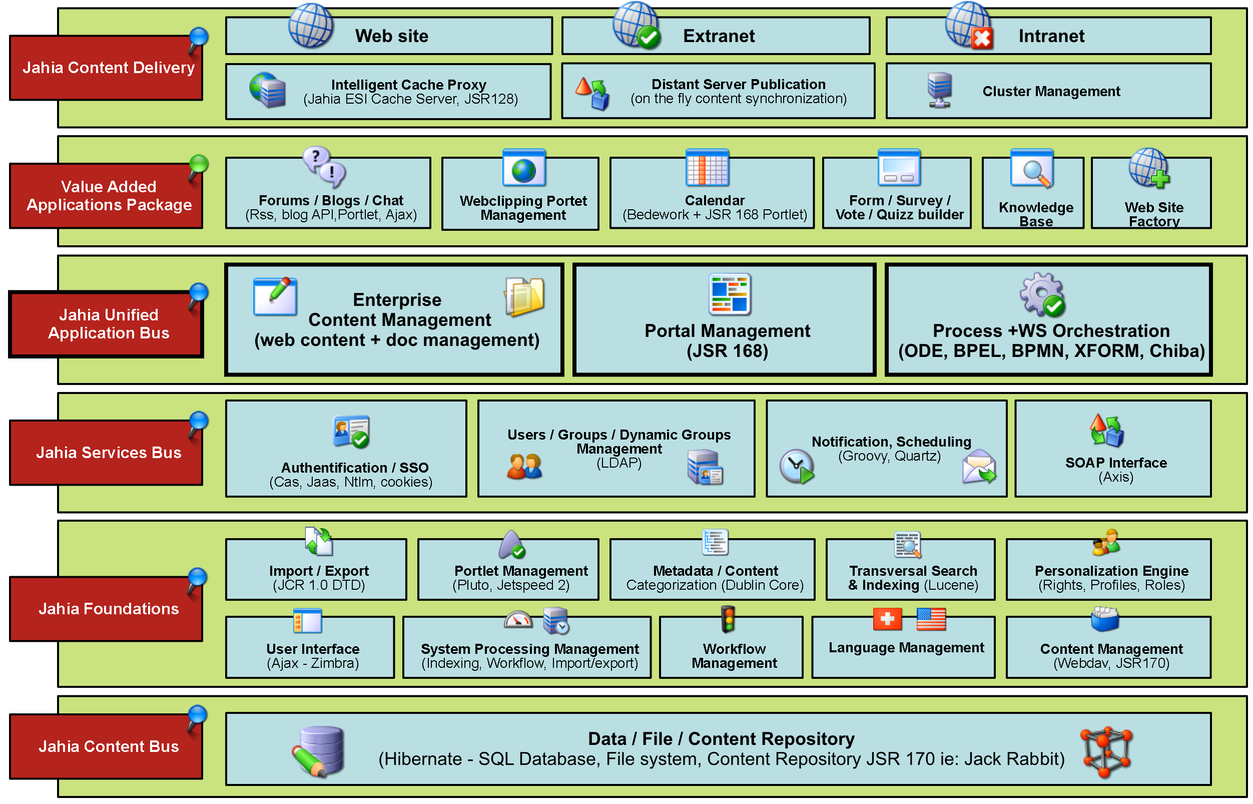
Figure 2-2: Architecture overview

Thanks to the native integration of CMS and a Portal features, Jahia may be used as a tool to manage your public web site or as a collaborative intranet/ extranet web space. You can even mix on the same web page, content (a text) and portlets (a discussion forum) as everything relies on a common and integrated platform.

New Features in Jahia Release 6
This release has seen major modifications to core elements of the platform, to update underlying frameworks (Hibernate, Spring, Jetspeed, Lucene, Tomcat 6), support current development tools and bring in new technologies (GWT/GXT, JCR/JackRabbit), to simplify and accelerate custom developments and extensions.
The development environment has been revamped to support Maven 2 and Bamboo.
The previous content repository framework, Slide, has been replaced by a more current content repository framework, JCR (also known as JackRabbit). This major rework will enable future versions to plug any JCR-compliant data source into the Jahia content bus, making access to multiple heterogeneous content repositories a breeze.
Significant efforts have also been made to improve platform performance overall, introducing HTML Container Cache with disk serialization as well as Navigation Tree Caching, to accelerate complex navigation tree renderings.
The single most visible change is the new look & feel of the administration and edition interface, which has been completely redesigned, to be overall more consistent. It has be rewritten using GWT, to enable robust AJAX interactions and give a smoother and faster user experience.
To simplify site usage analysis, the required Google Analytics code packages have been included into the template foundations.

Project scoping variables
As in all projects, before starting any implementation, a certain number of questions need to be asked to determine the influencing factors. In the case of the Jahia platform, there are 9 basic aspects that need to be inspected to determine the project scope and complexity.

Defining the Audience
Defining the audience (Intranet, Extranet or Internet) will allow you to determine if authentication and authorization will be required within your platform setup, as well as what authoring/editing and reader groups you may have. Note if they are there any restrictions on who can view the content.

Content Sharing
As the Jahia platform supports the presence of multiple virtual sites on one Jahia instance, as well as sharing of content between these sites, it is important to think about how theses sites will be managed and how the content will be reused/shared between the different virtual sites or parts of a given virtual site.

Demographics
To evaluate the initial system size and computational power required during the initial months/years of the system, one must have an idea of the potential demographics visiting the new site(s).
An estimation of the number of simultaneous and day-average visitors is required, broken down into Anonymous and Registered populations (to estimate extent of personalized content usage).
Then, on the content authoring side, you need to evaluate how many active content authors and total number of authors are expected.

Content Volumes
To determine the initial data storage volumes required, you need to estimate the number of pages and sites that will be hosted on the system, along with the number of files and total data volume that will be stored on the system.

Expected Evolution
To determine the probable evolution trend and infrastructure evolution required, re-evaluate the four previous point's evolution for the 12/24 months after platform launch, noting how your population is going to evolve. Determine if you already have an established population or if this build up and, if they are available, collect existing log analysis statistics.

System Architecture
If the system architecture you are going to run Jahia on is known, document it. A certain number of options will have definite impacts on the final system performance, so it is critical to identify them as soon as possible.
Note if you will be using:
- virtualized environments
- shared or dedicated systems
- clustered setups, with or without load-balancing
- remote publication/distribution
- separated authoring and publication environments
- dedicated indexing servers

Templating
Proper template design can have a major performance impact on the whole website, especially with highly dynamic features, such as blogs or news sites. As templating with Jahia is extremely flexible, most designs are feasible. Some issues may rise when using multiple Javascript frameworks, as they may conflict with each other. These issues can be resolved or at least detected early by creating a static (D)HTML mockup of the site(s). The site will be used a base for the templates.
What is also important to determine is if you will be using dynamic content retrieval, using the multi-axis categorization filters. In other words, will you be assigning categories to your content and selecting content to be displayed on the pages based on those categories. This is a very nice way to extract content, but can lead to performance issues if it is misused.

Integration with other applications
The Jahia platform supports the integration of external content through multiple methods: web clipping, JSR168-compliant portlets and the Jahia Java API. Note what you plan to use.

Content caching
To improve site display times when producing dynamically generated content, Jahia can cache the content and regenerate it at regular intervals, depending on given freshness criteria. Caching can also be used in specific template areas, especially useful when doing personalized pages which may contain a mix of static and high dynamic content.

Key project people
Document the names, contact details and responsibility area(s) of the people involved. This is always handy to have as a reference or for people who arrive later into the project. A good rule of thumb is : One person, One responsibility. Giving a same responsibility area to two different people could potentially cause project delays, due to misunderstanding, miscommunication or simple disagreement.

Typical Jahia project structure
Like all software platforms, there are always multiple paths to attain a same goal, some easier than others. Jahia is no different and developing your Jahia project in the appropriate manner will avoid you a lot of headaches later on in the project.
First of all, document as much as possible what is known before starting the actual project implementation:
- Project scope (see previous point)
- Project goals (Business case/Business project specifications)
- Rough project plan/milestone dates
Depending
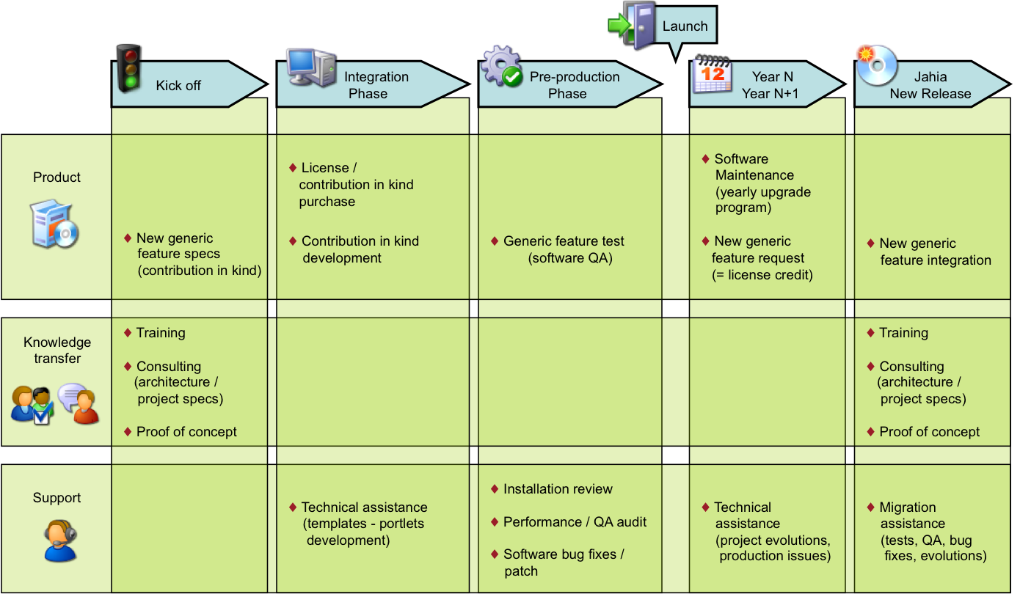

Key Jahia Features
Jahia provides the following key features to power your new portal or web site:
- Easy to Use Content Edition with support for various WYSIWYG HTML Editors
- Based on templates to clearly separate layout and content
- Full Multilanguage and Internationalization support
- Advanced Security Management
- Content Versioning
- Page Approval Workflow
- Native support for Portlets (Web Applications and Web Services)
- Virtual Site Management
- Integrated Search Engine
- Document Management System
- Full web based Administration Center

Definition of user roles in Jahia
Jahia enables complex access and modification rights management, defined through users and user groups (which can be considered as “roles”). Any given user can belong to multiple user groups, allowing him/her to have different roles in different parts of the Jahia platform, similar to how Unix user management is done.

A brief history of Jahia

Blobs
- Guest (anonymous): This "user" is provided by default on all the Jahia installation. It allows non authorized users (anonymous user) to access part or all of your web site. When you published an Internet based web site, unregistered external users will be tacitly logged into the system with this profile.
- Reader: the Readers are registered Jahia users who can login into the system. Thanks to their authentication, they may access private areas (intranet or extranet areas) and also to their personalized settings (their personal information such as their e-mail address, their languages preferences,…). A reader has "read-only" privileges and can not switch in edit mode to modify content.
- Author: The Authors, unlike the Readers, may modify the site content. They may access all the functions related to the edition and modifications of part or all of the web site. So an Author may be a Portal User that needs to edit some portlets and content on his personal home page. It may also be a Redactor or a Translator in charge of editing complete sections of the web site.
- Manager: The Managers approve content modifications before it goes live. They can also modify the permission rights (who can access to which section or which content object) or to the activity logs. They have the same privileges as the Authors regarding content modifications. You can be a Manager on some pages and only an Author or a simple Reader on another section of the portal.
- Site Administrator: On the same Jahia server, you can host several independent web sites (e.g. one for each department). Each web site has one or several Site Administrators that can access to the Site Administration Center interface. The Administration Center lets the Site Administrators manage the global settings of the current web site such as registering new users and groups, adding new templates or setting the site languages or the default home page for each users. Every Site Administrator has full access will all privileges on its virtual web site, and several Site Administrators can be set up for each virtual site.
- SuperAdministrator/ Root: Each physical Jahia Server has a Root user (System Administrator). This user can access to all the virtual web sites with all privileges and can also access to the low-level menus in the Administration Center (database settings; backup services;…).

The Jahia Publishing process
The second important point to keep in mind while using Jahia is the basic flow of information
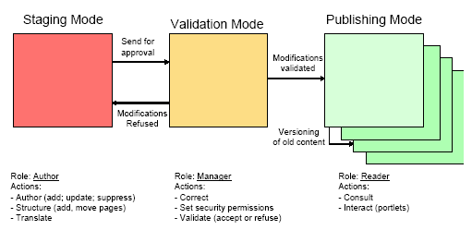
Figure 2-3: Publishing Process

The usual flow is defined in the following manner:
- One or several authors enter or modify content. Once the modifications or translations are done (e.g. the creation of a new Marketing section), they send a request for approval to a Manager.
- A Manager is then in charge of reviewing the changes, modifying if necessary the permission rights and validating the content before publishing.
- Once approved, the new content is then available to the Readers. A version of the previous content is automatically stored in the system as an archive (versioning).
This is the usual flow of information in Jahia. However it is also possible to have web sites without any validation step (the content is then immediately published to the users - useful for intranet and collaboration web space purposes for example) or without versioning (no archiving of previous content). It is also possible to integrate Jahia with third party tools such as a more complete workflow server that will require you to follow a complete validation path with several approvals steps before the content goes live.

